Magica Roma
RISTORANTE ITALIANO
Takeaway Menu
0215311489

THE PLEASURES OF THE TABLE BELONG TO ALL TIMES AND ALL AGES, TO EVERY COUNTRY AND EVERY DAY, THEY GO HAND IN HAND WITH ALL OUR OTHER PLEASURES, OUTLAST THEM, AND REMAIN TO CONSOLE US FOR THEIR LOSS.

A WELL CO-ORDINATED MEAL IS ONE OF LIFE’S GREAT PLEASURES, AND TO BE SURROUNDED BY DELICACIES IS A LUXURY OF MAN.

Antipasti Freddi
Fresh Wild Oysters R35 each
Shrimp Cocktail R99
Parma Ham R175
Marinated Smoked Salmon Magica Roma R130
Dressed in lemon, olive oil & black pepper
Beef Carpaccio Magica Roma R135
Tuna Carpaccio Magica Roma R135
Peperoni in Bagna Cauda R95
Grilled red peppers dressed with olive oil, anchovies & garlic
Antipasto Italiano R175
A selection of Italian salami, parma ham, grilled red peppers, artichokes, olives & caprese

Antipasti Caldi
Snails in Garlic Butter R105
Fried Calamari R115
Baby Calamari Tubes, Chilli & Garlic R115
Black Mussels in Cream & Garlic R99
Italian Polenta with Gorgonzola Cheese R135

Zuppe E Minestre
Minestrone R89
Cream of Mushroom R89
Cream of Tomato R89
Mussel & Clam Chowder R125
Cream, garlic, mussels & vongole soup

Insalate
Small Medium Large
Greek R120 R150 R220
Italian R120 R150 R220
Insalata della Casa R140 R170 R250
Mixed leaves, avocado, olives, feta cheese & mozzarella
Tricolore R140 R195
Thinly sliced tomatoes, fior di latte mozzarella & avocado, dressed with olive oil & lemon juice

Le Pizze

Margherita Cheese, tomato & oregano R135
Napolitana Anchovy R150
Four Seasons Mushrooms, olives asparagus & artichokes R160
Norvegese Smoked salmon, capers & black pepper R200
Mediterranean Grilled calamari, chilli & garlic R200
Quattro Formaggi Mozzarella, feta, pecorino & gorgonzola R170
Romulus Ham, salami & chilli R165
Magica Roma Ham & mushrooms R160
Garlic & herb Focaccia R95

Pizza Toppings:
R10:
Chilli, Garlic
R14:
Banana, Apple, Onion, Caramelised Onion, Basil, Pineapple, Spinach, Tomato, Red Peppers, Green Peppers
R18:
Capers, Pepperdews, Rocket, Olives, Sundried Tomato
R24:
Anchovies, Asparagus, Mozzerella, Mushroom, Baby Tomato
R31:
Feta, Gorgonzola, Grilled Vegetables, Artichokes, Ham, Beef, Bacon, Tuna, Salami
Avocado R45 Parma Ham R98
Chicken R50 Smoked Salmon R106
Fior Di Latte R51 Shrimps R49
Calamari R75 Anchovies R25

Le Paste
Spaghetti Aglio Olio e Peperoncino R140
Garlic, olive oil & chilli
Penne Arrabbiata R150
Fresh tomato, chilli & garlic
Napoletana Sauce R140
On pasta of your choice
Bolognese Sauce R175
On pasta of your choice

Tagilatelle Alfredo R180
Cream, mushrooms & ham
Ravioli Alfredo R185
Meat filling, cream, mushrooms & ham
Penne Giovanni R180
Ham, mushrooms, tomato & chilli

Linguine Carbonara R180
Bacon, onion, cream & parmesan
Spaghetti Amatriciana R180
Bacon, onions & tomato

Cannelloni di Magro R175
Ricotta cheese, spinach & baby marrow
Beef Cannelloni Magica R185
Penne Al Forno R185
Bolognese, mozzarella, pecorino, oven baked

Linguine Montanara R190
Veal ragu, mushrooms, onion & tomato
Spaghetti allo Scoglio R230
Assortment of seafood & shrimps with chilli & garlic sauce
Penne Della Casa R170
Grated vegetables, tomato & cream sauce

Il Pesce

Sole Meunier SQ
Lemon butter, Garlic butter or Olive Oil & Fresh Lemon
Kingklip R280
Lemon butter, Garlic butter or Olive Oil & Fresh Lemon
Kingklip Magica Roma R280
Tomato, cream, garlic

Black Mussels Cream & Garlic R195
Fried Calamari R255
Grilled Baby Calamari Tubes R255
With chilli & garlic

Zuppa di Pesce Grande R250
Large mixed seafood soup served with garlic bruschetta
Mixed Seafood Platter R490
Linefish, prawns, fried calamari, mussels & grilled calamari tubes
Prawns
Side seasonal vegetables R39.50

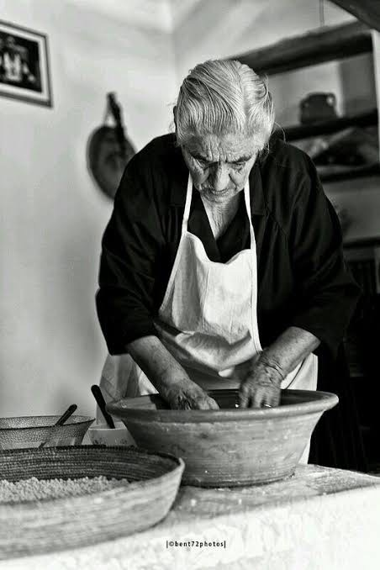

Le Carni

Beef Fillet SQ
Cheese, Mushroom, Pepper, Chasseur, Magica Roma or Voronoff Sauce
Tagliata Fiorentina SQ
Sliced grilled fillet, dressed with our special olive oil, balsamico & herb sauce

Ribeye SQ
Served Sliced on a bed of Grilled spinach, topped with Caramelised Onion and a Savoury Sauce

Lamb Loin Cutlets Magica Roma R295
Mozzarella, garlic & soya gravy
Lamb Loin Cutlets Bourguignon R295
Grilled in garlic & herb butter
Side seasonal vegetables R39.50

Vitello
Scaloppine di Vitello Isacco R290
Lemon, white wine, mushroom & sage
Veal Marsala R290
In marsala wine sauce
Piccata Al Limone R290
Lemon butter
Schnitzel Milanese R290
Saltimbocca Magica Roma R299
Ham, mozzarella & mushroom sauce
Side seasonal vegetables R39.50

Pollo
Petto di Pollo alla Fiorentina R230
Grilled chicken breast served on grilled spinach dressed with our special olive oil, balsamico & herb sauce
Petto di Pollo Milanese R230
Chicken breast schnitzel
Side seasonal vegetables R39.50

